Project Report

Gaussian Mixture Models: Bag of Words Representation

Name: Revanth Kalluri
Course: AI & ML (Batch-5)
Problem Statement: Apply Gaussian Mixture Model to perform clustering.

Prerequisites:
Software used and how I installed them:
Python 3.6: Download and install anaconda using https://www.anaconda.com/download/. After installing anaconda, install below modules(packages), using anaconda prompt to run the commands.
Module | Command
numpy | pip install numpy
sklearn | pip install scikit-learn
pandas | pip install pandas
matplotlib | pip install matplotlib

Pip is a package manager for python packages. Run “pip --version” in anaconda prompt to verify if pip is already installed. Run “conda install pip” to install pip for the first time.

Dataset used:
The dataset used is Clustering_GMM available at - https://cdn.analyticsvidhya.com/wp-content/uploads/2019/10/Clustering_gmm.csv

Method used:
Gaussian Mixture.

1. Importing necessary modules:
2. Read Clustering GMM data:
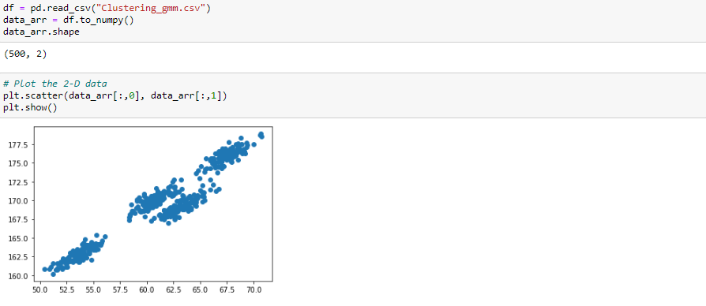
3. Implement GMM on data and plot the results:
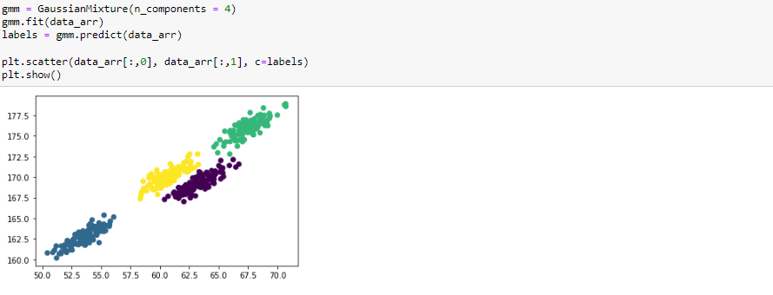

4. Create dummy data using make_blobs from sklearn.datasets:
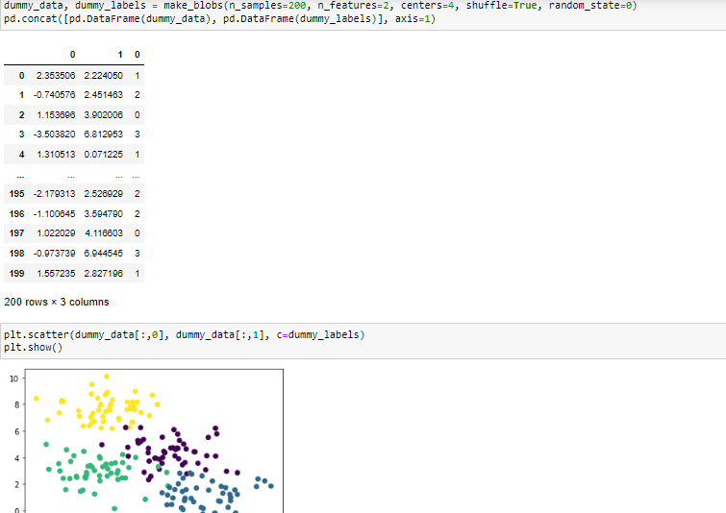
5. Implement GMM on artificial data and plot the results:
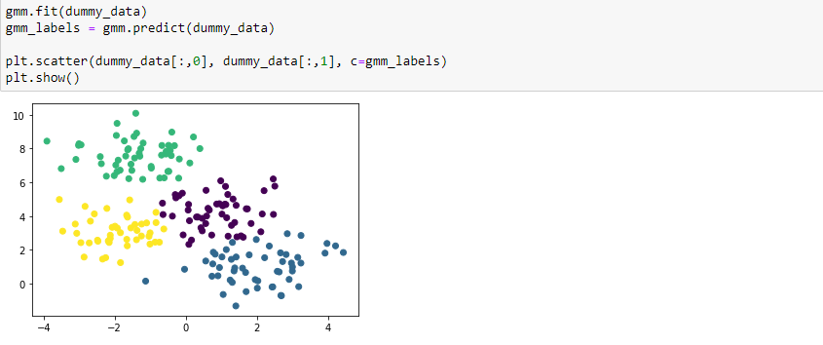

6. Show probable classes for each data point:
